SIMATS ENGINEERING
ASSESSMENT TOOL 1
COURSE NAME: Database Management Systems NAME: Mahadevan.R
COURSE CODE: CSA05 REG:192521134
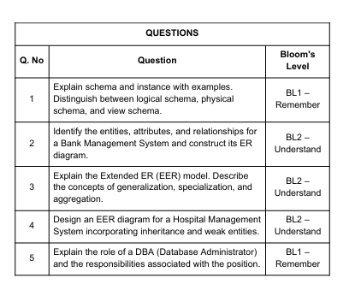

Code of Conduct: I am Mahadevan.R(192521134) certify that this submission is my original work and that I have adhered to the guidelines specified for this assessment. I understand that any violation of academic integrity rules will result in disciplinary action.

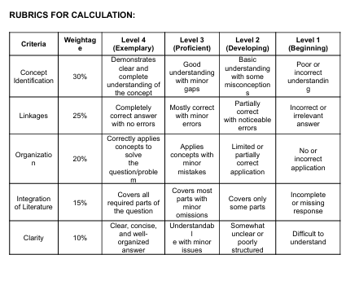

Explain schema and instance with exampls distinguish between logical schema, physical schema , and vie schema.

Schema and Instance in DBMS
1. Schema
A schema is the overall logical structure or design of a database. It describes:
- Tables
- Attributes/columns
- Data types
- Relationships
- Constraints
Logical Schema (Conceptual Schema)
The logical schema describes the complete logical structure of the database.
It includes:
- Tables
- Attributes
- Relationships
- Constraints
STUDENT(Student_ID, Name, Department, Age)
COURSE(Course_ID, Course_Name)
ENROLLMENT(Student_ID, Course_ID)

Identify the entities attributes and reletionshipn for a bank managemnet b system and construct its ER diagram
1. Entities and Attributes
Customer
- Customer_ID (Primary Key)
- Name
- Address
- Phone
Account
- Account_No (Primary Key)
- Account_Type
- Balance
Branch
- Branch_ID (Primary Key)
- Branch_Name
- Location
Loan
- Loan_ID (Primary Key)
- Loan_Type
- Amount
Transaction
- Transaction_ID (Primary Key)
- Transaction_Date
- Amount
Explain the extended ER model describe the concepts of generalization specification and aggregateion
Extended ER (EER) Model
The Extended Entity-Relationship (EER) model is an enhanced version of the basic ER model. It provides additional concepts to represent complex real-world data and relationships more accurately. The major concepts of the EER model include specialization, generalization, and aggregation.
Generalization
Generalization is a bottom-up approach in which two or more lower-level entity sets are combined to form a higher-level entity set based on their common features.

Aggregation
Aggregation is a concept used to represent a relationship between an entity and a relationship set as a higher-level entity. It is useful when a relationship itself participates in another relationship.

Design an ER diagram for a Hospital Management System incorporating inheritance and weak entities.

ER Diagram for a Hospital Management System
The hospital management system uses inheritance to represent different types of people and a weak entity to represent dependent entities.
Explanation
Inheritance: Person is the supertype, while Doctor and Patient are subtypes that inherit common attributes such as Person_ID, Name, and Address. Doctor is further specialized into Surgeon and Physician.
Weak Entity: Patient_Record is a weak entity because it cannot be uniquely identified without the associated Patient. It depends on the Patient entity for its identification and existence. Its partial key, such as Record_No, combines with Patient_ID to uniquely identify each patient record.
Relationships: A doctor treats patients, a patient has patient records, and appointments are used to connect doctors and patients for consultation.

Explain the role of a DBA (database admistrator) and the responsibilitis associated with the position
Role and Responsibilities of a DBA
A Database Administrator (DBA) is a professional responsible for managing, maintaining, securing, and ensuring the efficient operation of an organization's databases. The DBA ensures that data is available, accurate, secure, and accessible to authorized users.
Major Responsibilities of a DBA
- Database Design and Installation – Creates and configures databases according to organizational requirements.
- Database Security – Controls user access and permissions to protect data from unauthorized access.
- Backup and Recovery – Regularly backs up data and restores databases in case of data loss or system failure.
- Performance Monitoring and Tuning – Monitors database performance and optimizes queries, indexes, and storage for efficient operation.
- Data Integrity and Consistency – Ensures that data remains accurate, consistent, and reliable by enforcing constraints and rules.
- User and Access Management – Creates user accounts and assigns appropriate roles and privileges.
- Database Maintenance – Performs updates, upgrades, troubleshooting, and routine maintenance.
- Disaster Recovery – Develops plans to recover database systems after hardware failures, cyberattacks, or other disasters.

